Lab 3

Part 1 (prelab)

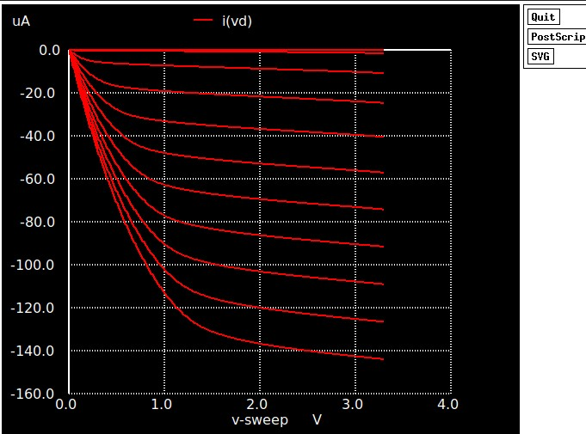

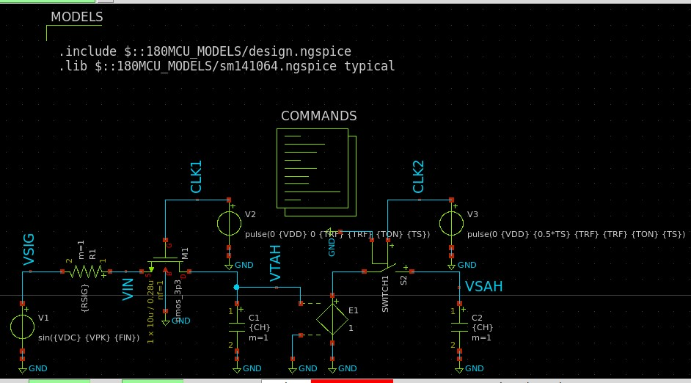

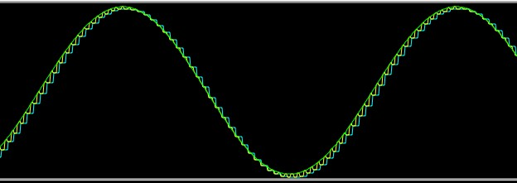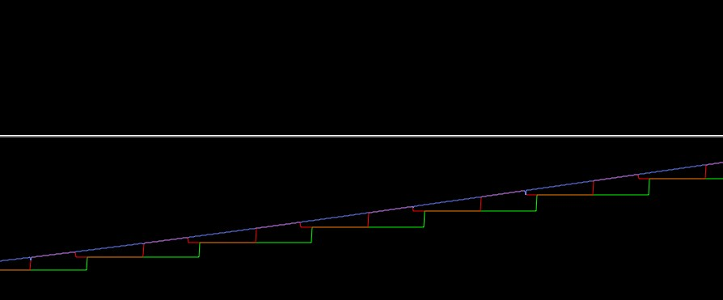

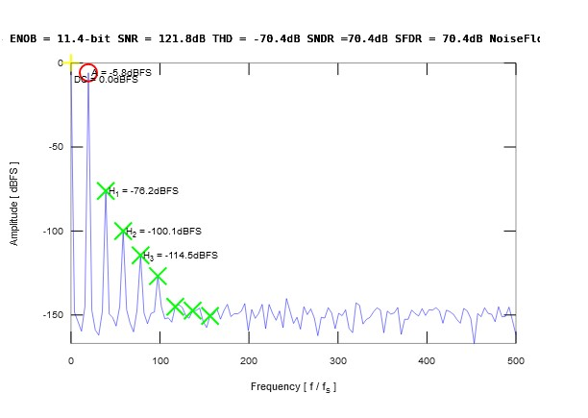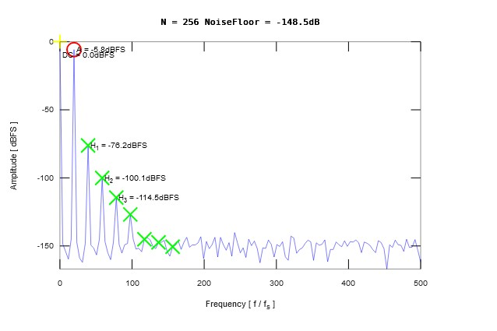

|  |  |  |
| --- | --- | --- |
|  | Lab3 | Lab2 |
| ENOB | 11.4 bit | 20.4 bit |
| SINAD | 70.4 db | 124.4 db |
| SNR | 121.8 db | 124.8 db |
| SFDR | 70.4 db | 139.5 db |
| THD | -70.4 db | -136.2 db |
| SIGNAL POWER | -8.85 db | -9 db |
| DC POWER | 0 db | 0db |
| Highest harmonic | Second harmonic  (H1) | Fourth harmonic (H3) but with weak effect |

From the result we observe that replacing an ideal switch with Nmos increased the harmonic effect in frequency domain .

Second harmonic has large power decreasing noise floor .

This observable harmonic effect leads to decreasing SNR , SNDR THD SFDR and the effective number of bits .

Replacing an ideal switch with a practical NMOS transistor introduces signal-dependent resistance, parasitic capacitances, charge injection, and body effect, all of which contribute to nonlinear distortion. These effects are asymmetric, which enhances even-order harmonics, particularly the second harmonic

PART 2

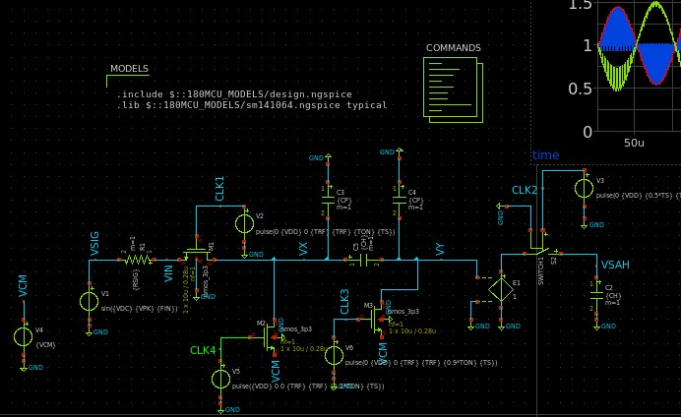

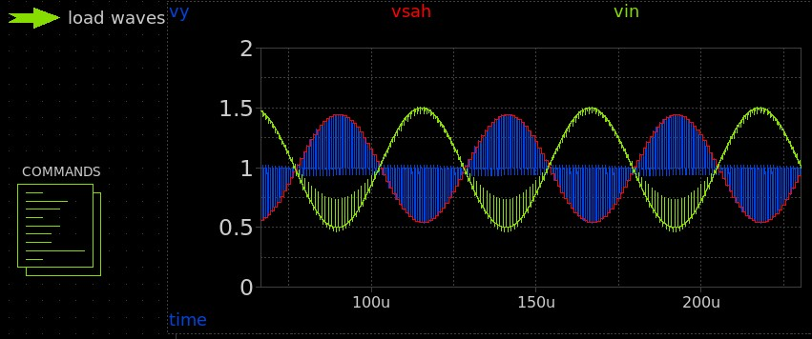

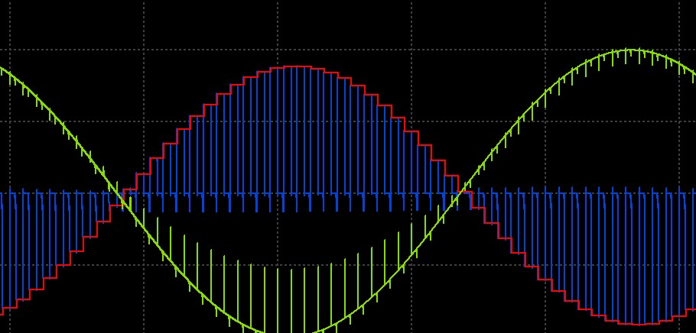

FFT:

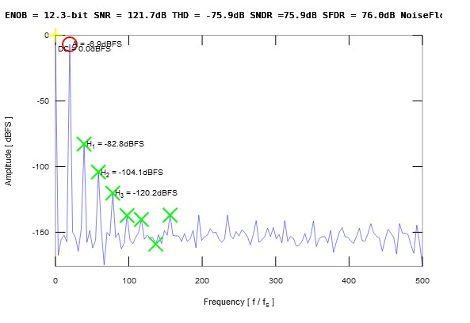

|  |  |  |
| --- | --- | --- |
|  | Part 1 | Part 2 |
| ENOB | 11.4 bit | 12.3 bit |
| SINAD | 70.4 db | 75.9 db |
| SNR | 121.8 db | 121.7 db |
| SFDR | 70.4 db | 76 db |
| THD | -70.4 db | -75.9 db |
| SIGNAL POWER | -8.85 db  (-5.8db rms) | -13.8 db  (-6.9db rms) |
| DC POWER | 0 db | 0db |
| Highest harmonic | Second harmonic  (H1) | Second harmonic  (H1) |

from the plot we can see that bottom plate sampling enhance SFDR and SNDR due to decreasing the effect of harmonic distortion

SNR is nearly the same as the harmonics doesn’t affect it

Signal power is affected with the bottom plate parasitic capacitance

The effective number of bits increased .

A practical NMOS transistor introduces signal-dependent resistance, parasitic capacitances, charge injection, and body effect, all of which contribute to nonlinear distortion. These effects are asymmetric, which enhances even-order harmonics, particularly the second harmonic

**Part 3:**

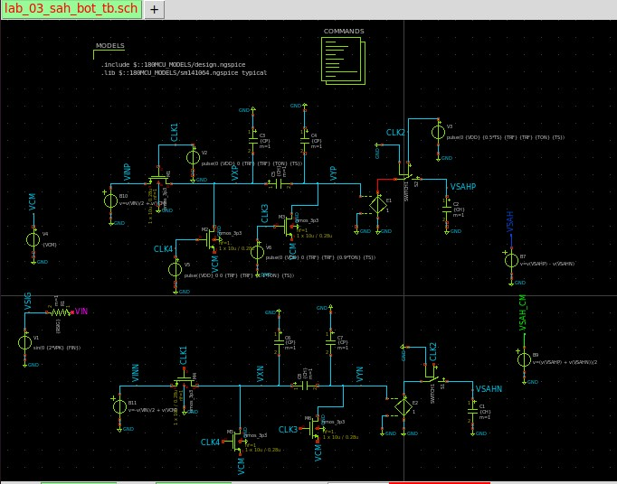

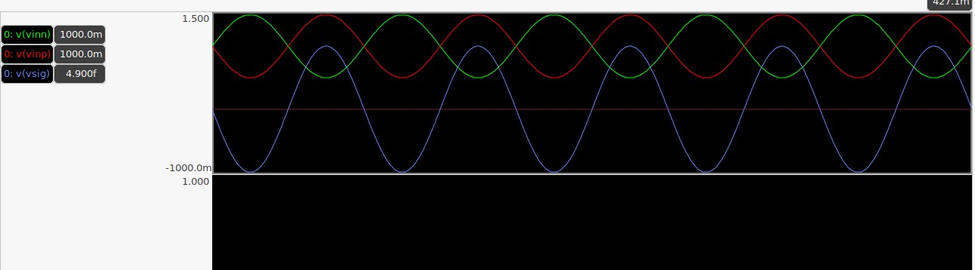

**Differential output**

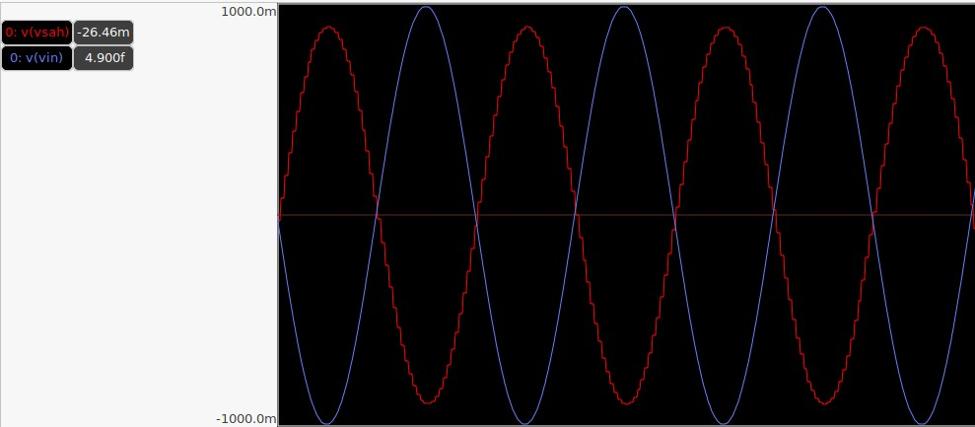

**Comment:**

Remains equal to the input peak-to-peak differential voltage but inverted.

Less distortion compared to a single-ended design and rejects even harmonics

**Common mode waveform:**

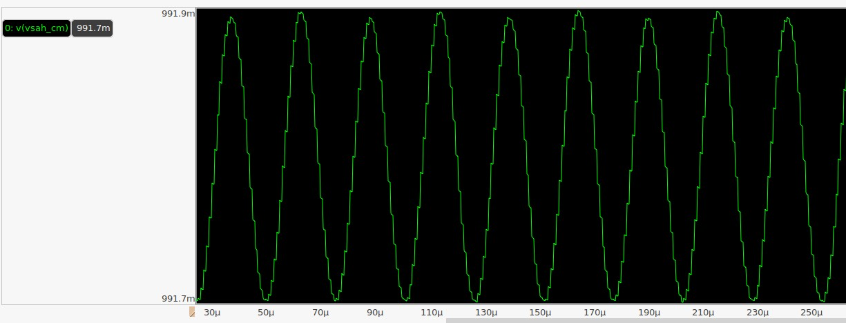

**Comment :**

Ideally constant but may exhibit small ripples due to mismatches.

Should be well-controlled to ensure minimal interference with the differential signal.

**FFT:**

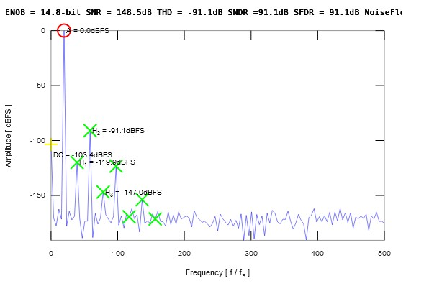



|  |  |  |
| --- | --- | --- |
|  | Part 3 | Part 2 |
| ENOB | 14.8 bit | 12.3 bit |
| SINAD | 91.1 db | 75.9 db |
| SNR | 148.5 db | 121.7 db |
| SFDR | 91.1 db | 76 db |
| THD | -91.1 db | -75.9 db |
| SIGNAL POWER | 0 db | -9.8 db  (-6.9db rms) |
| DC POWER | 0 db | 0db |
| Highest harmonic | Third harmonic  (H2) | Second harmonic  (H1) |

We can notice that using fully differential circuit enhanced both the SNR and SNDR as it helps in canceling even-order distortions, improving linearity, and reducing supply noise sensitivity.

The rejection of even harmonics enhanced SFDR and now the third harmonic has the most peak .

The effective number of bits and signal power increased .

**Bootstrabing circuit**

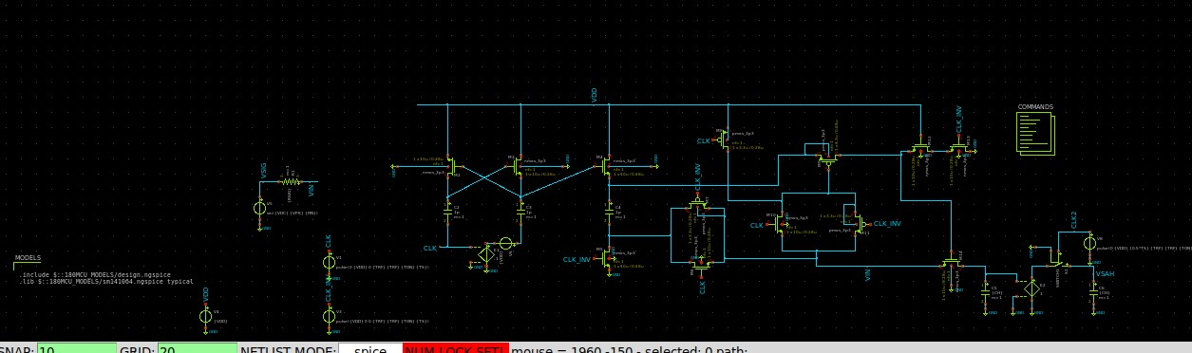

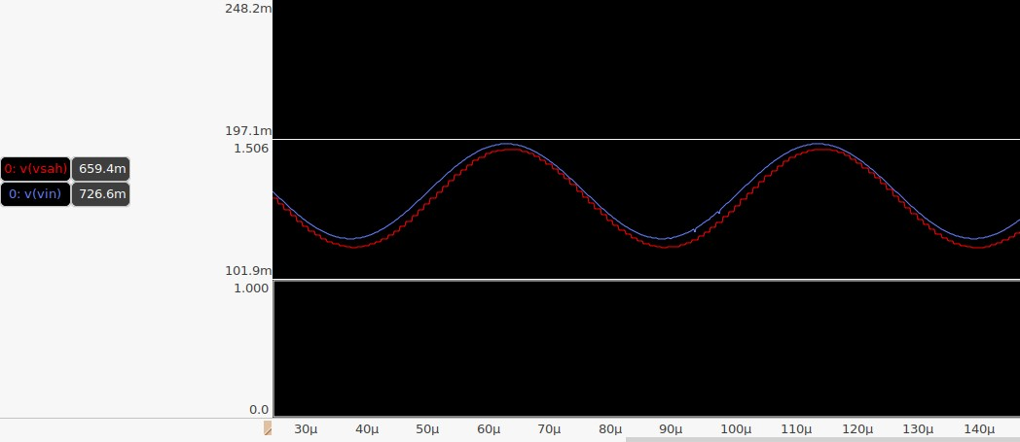

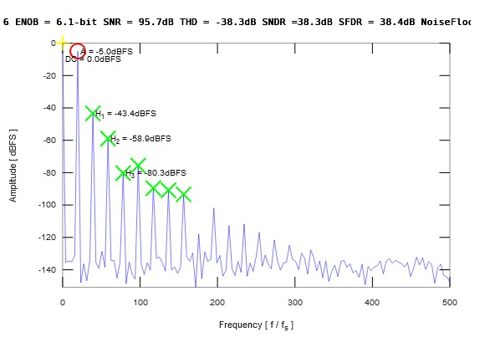

We notice that the effective number of bits is low compared to the last parts and the harmonic distortion is highly observed .